## **Parachute Release Mechanism: Hardware Materials and Setup**

**Problem Statement**

Our team will be designing and building a drop apparatus for the ENGR 101 parachute project. We will integrate MATLAB and Arduino software to control a redboard, relay and solenoid to release the parachutes by activation of a physical button.

**Hardware Setup:**

Bill of Materials:

|  |  |  |  |  |
| --- | --- | --- | --- | --- |
| Part Name | Purpose | Item Name | URL | Price |
| Arduino  (Receive from ENGR 114 Class) | It can connect with computer or laptop and run with Arduino and MATLAB code to operator sensors, lights | SparkFun RedBoard - Programmed with Arduino | https://www.sparkfun.com/products/13975 | $ 19.95 |
| Breadboard  (Receive from ENGR 114 Class) | A board can easy to connect the Arduino board with the cores to connect the power to the thing we want to connect | Breadboard - Self-Adhesive (White) | https://www.sparkfun.com/products/12615 | $ 4.95 |
| USB cable  (Receive from ENGR 114 Class) | Transfer the data from the computer or laptop to the red board and also can support the power as 1.5 volt to the red board run | SparkFun USB Mini-B Cable - 6 Foot | https://www.sparkfun.com/products/11301 | $ 3.95 |
| Job box  (Receive from ENGR 114 Class) | Setup the hardwares inside this box for easy to carry and protect them for weather | Big Red Box - Enclosure | https://www.sparkfun.com/products/11366 | $ 8.95 |
| Solenoid  (Receive from ENGR 114 Class) | Push - pull to drop or hangthe parachute | Large push-pull solenoid | https://www.adafruit.com/product/413 | $ 14.95 |
| Jumper wires  (Receive from ENGR 114 Class) | The core help connect the power from red board to breadboard and breadboard to the solenoid | Jumper Wires Standard 7" M/M - 30 AWG (30 Pack) | https://www.sparkfun.com/products/11026 | $ 1.95 |
| Diode  (Receive from ENGR 114 Class) | eliminate transient voltages caused when a magnetic coil (such as those found in a motor, relay, or solenoid) suddenly loses power. Without this diode in place the transient voltage spikes can damage other elements of the circuit. | Schottky Diode | https://www.sparkfun.com/products/10926 | $ 0.15 |
| Power transistor  (Receive from ENGR 114 Class) | For controlling the solenoid and the power from the very low to the height power | FQP30N06L 30N06L 30N06 | https://www.aliexpress.com/item/Free-shipping-FQP30N06L-30N06L-in-stock/32234508850.html?aff_platform=promotion&cpt=1544242252747&sk=ZRFybm6&aff_trace_key=cdd48b5365ad424f889402622d51e227-1544242252747-04070-ZRFybm6&terminal_id=0e86cdc9f29642a9b35965df5e412761 | $ 17.98 for 100 piece |
| 1K ohm resistor  (Receive from ENGR 114 Class) | Commonly used in breadboards and perf boards, these 330 Ohm resistors make excellent for solenoid current limiters and are great for general use | Resistor 330 Ohm 1/6 Watt PTH - 20 pack | https://www.sparkfun.com/products/11507 | $ 0.95 |

**Hardware Schematic:**

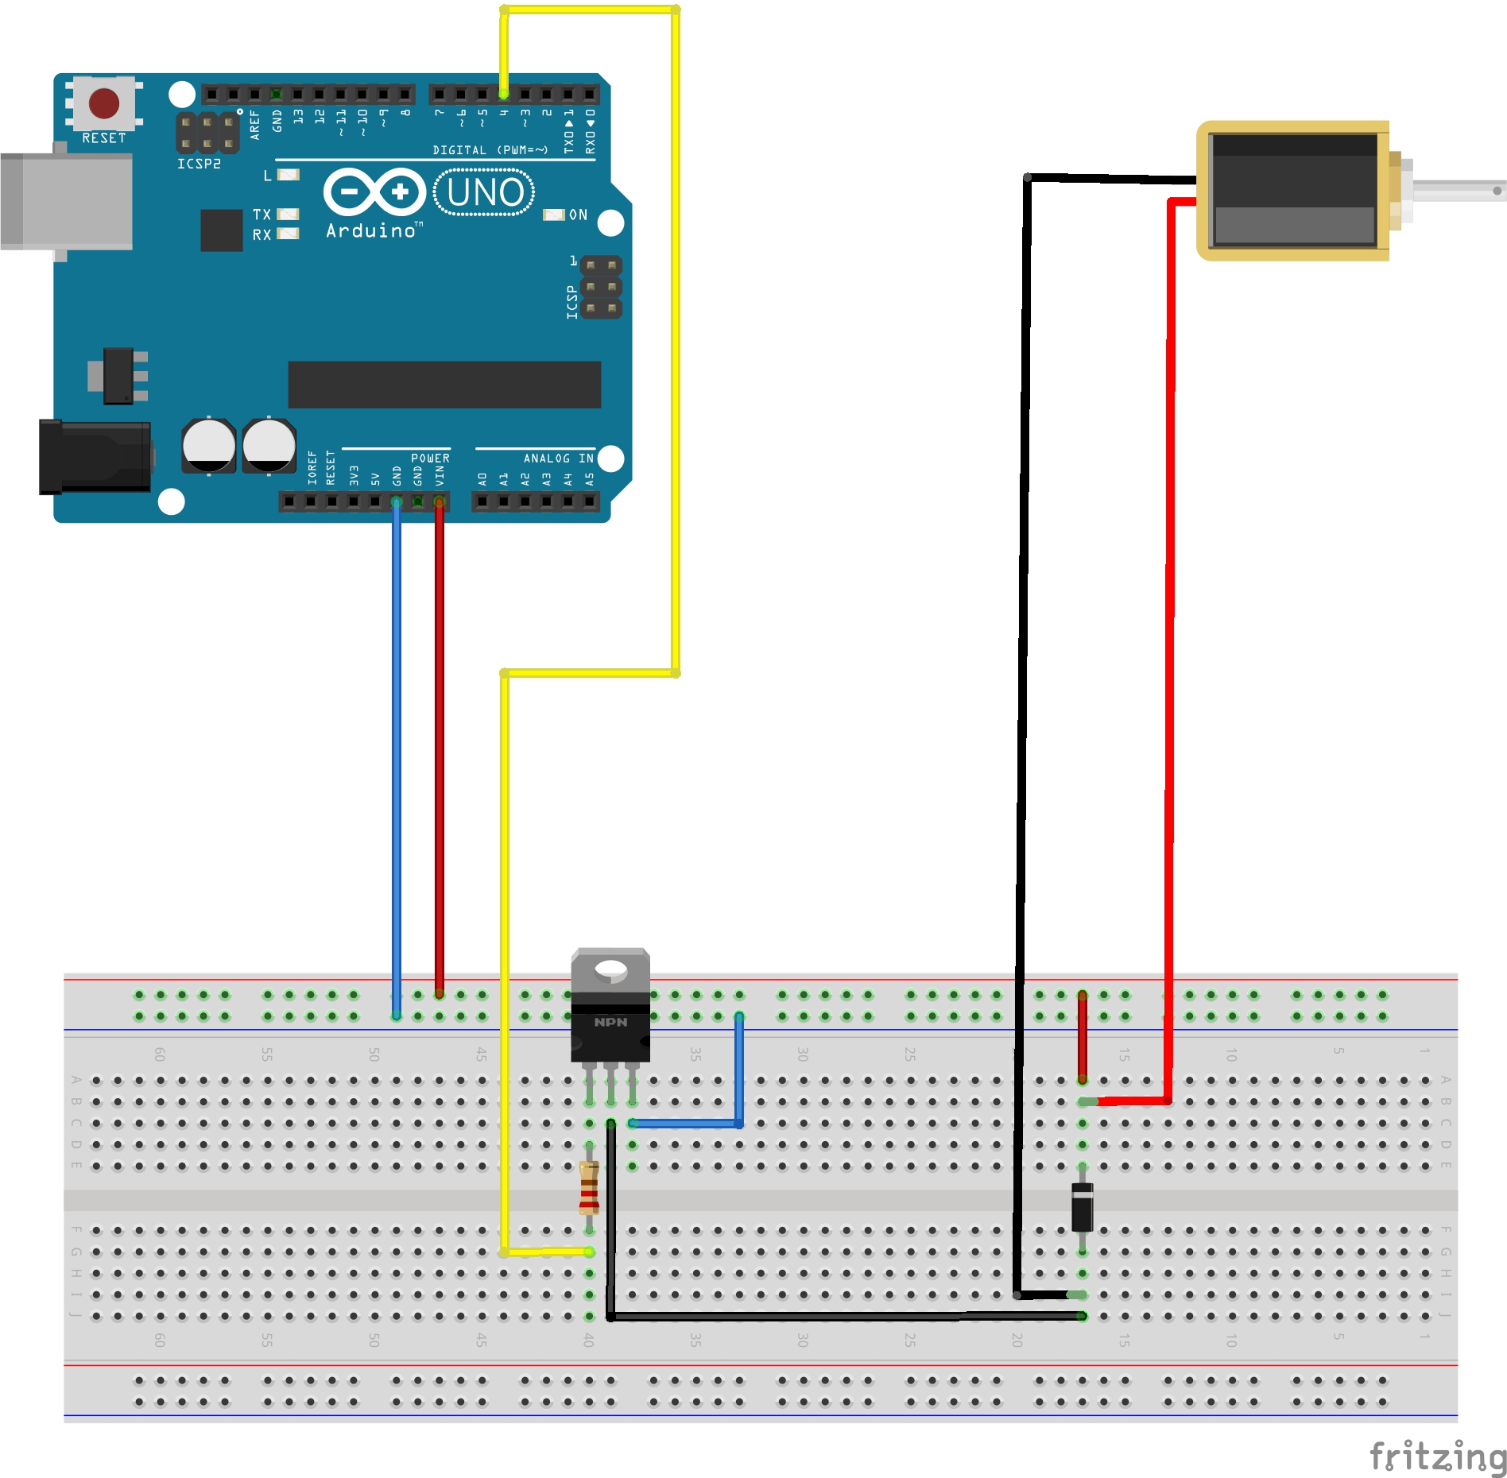

**Hookup Guide:**

**Step 1- Powering The Breadboard**

Start by connecting one of the jumper wires to the “Vin” pin located next to the GND(ground) on the Reboard and running it over to the positive side of breadboard. And then run a wire from the GND pin on Redboard over to negative rail on the breadboard.

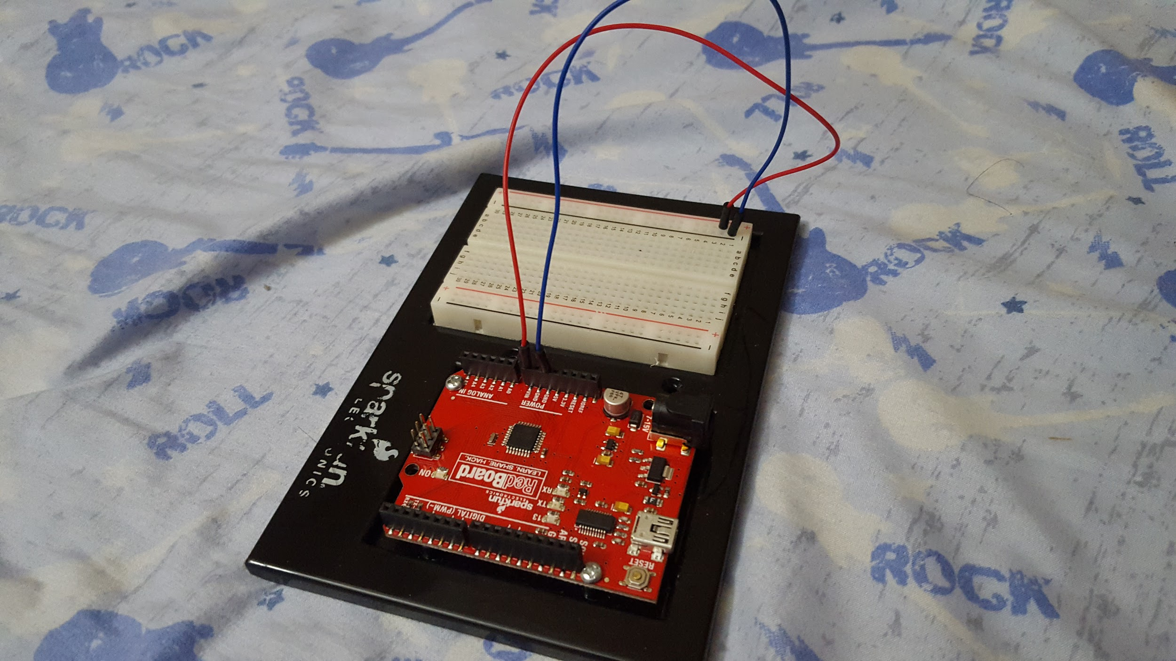

**Step 2 - Wire Solenoid To Breadboard**

Connect the solenoid wire(just the wire) to the breadboard. Also,we will need to add a diode between the two contacts so we will leave some space for that.

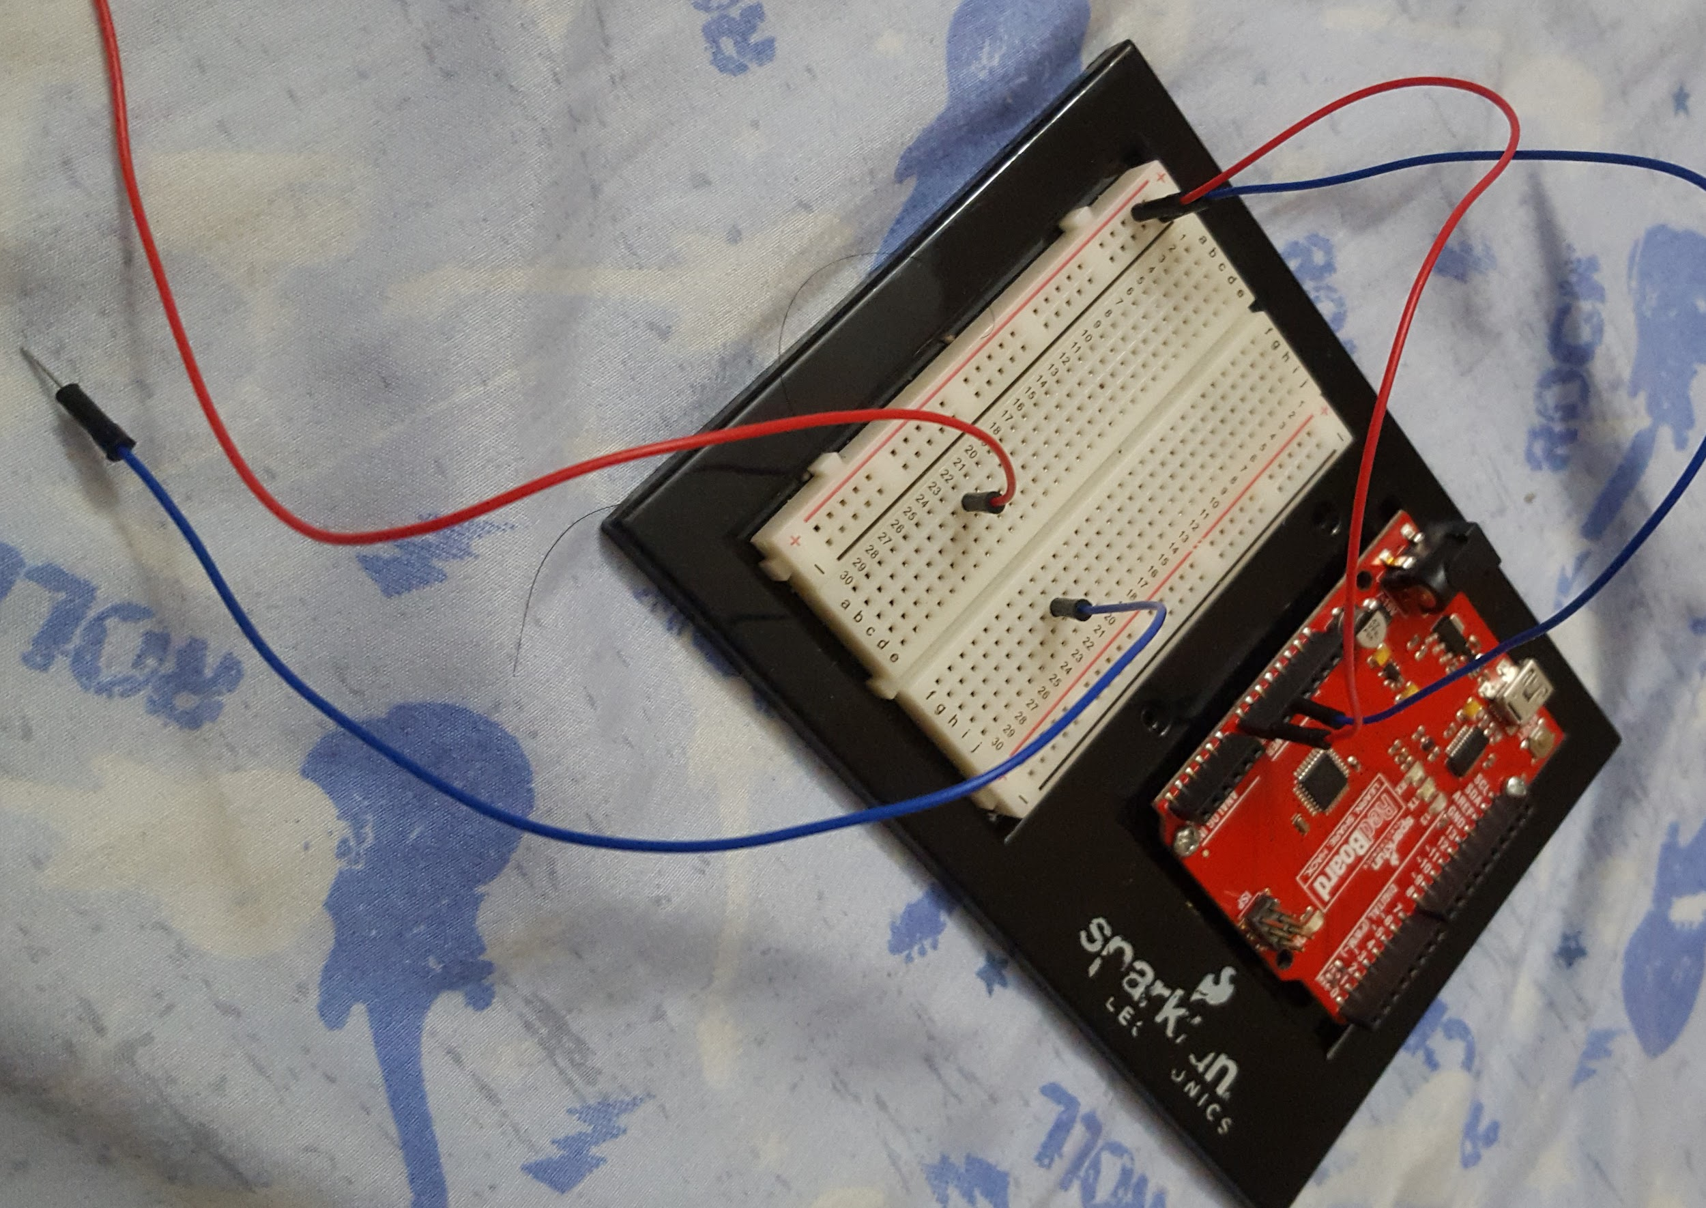

**Step 3 - Place the Diode on the breadboard**

The Diode is placed from the negative side of the coil to the positive side. Be Careful when you connect the diode, it allow current to flow in one direction we need to make sure we get the right. Also, it will be dead short between power and ground. Make sure the side with the white stripe is connect to positive side of power and another side connect to the negative side

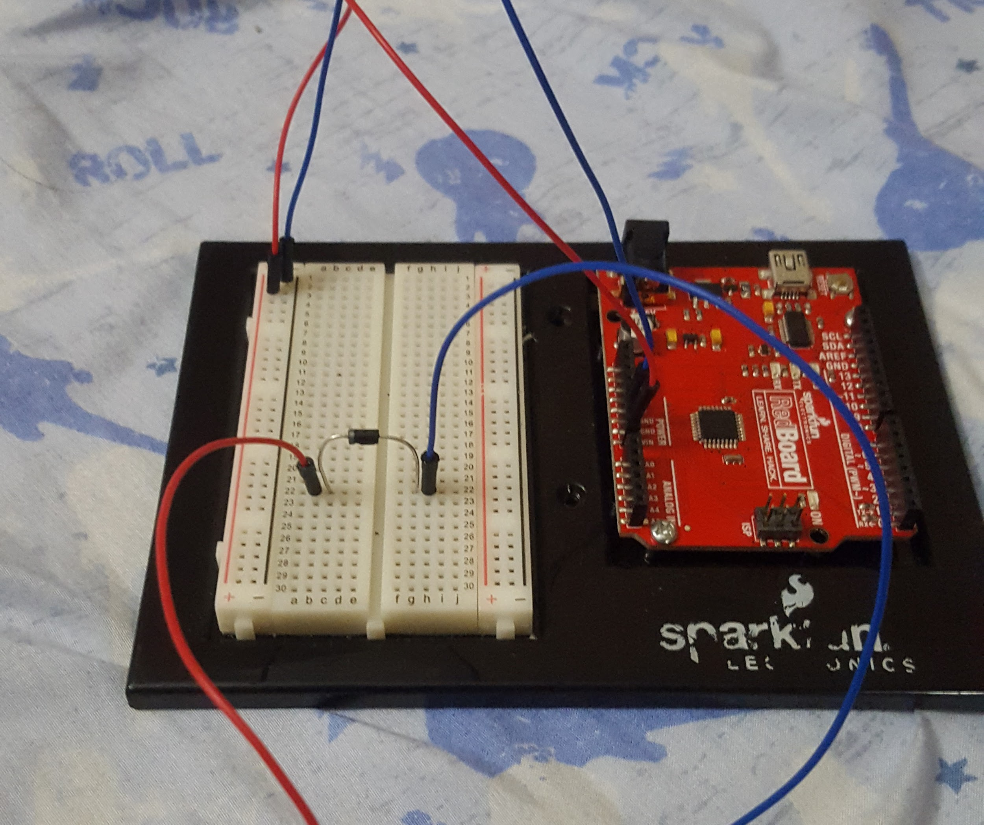

**Step 4 - power to the solenoid wire**

On this step we run the wire from the positive power side of the board to positive wire of of solenoid wire next to the hole. The solenoid wire contact to power because we will use low side to turn on or off it.

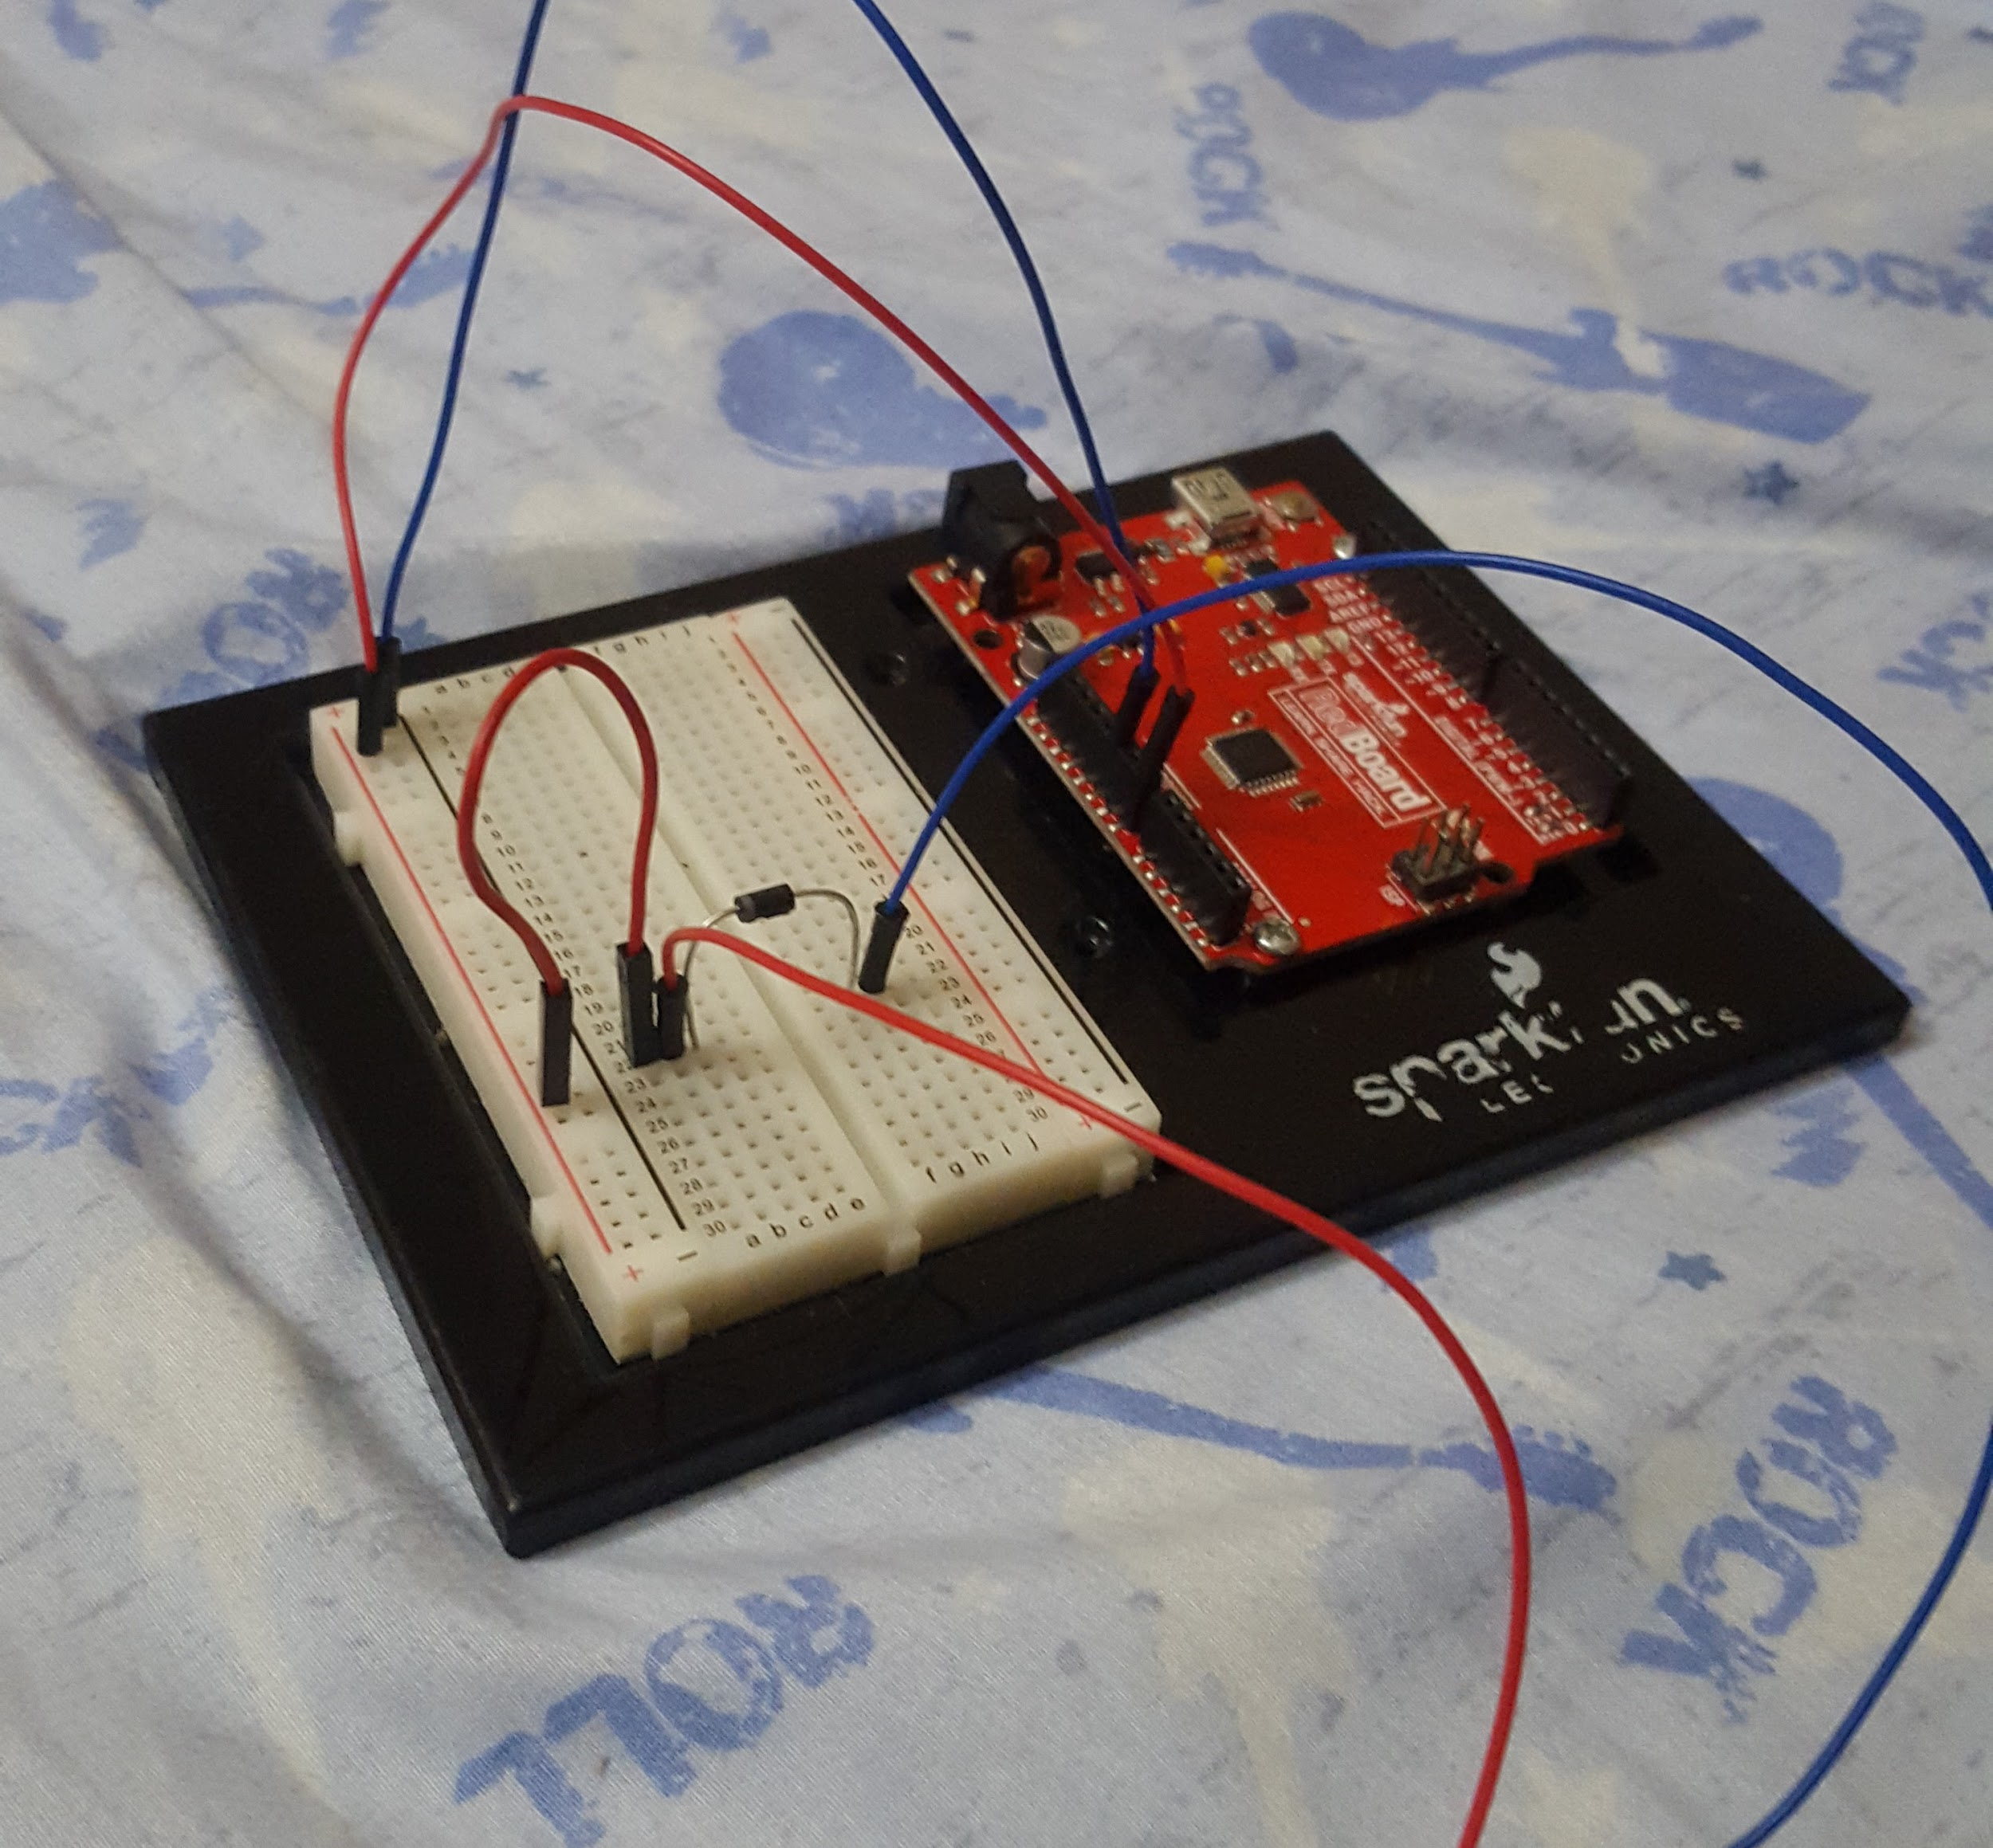

**Step 5 - place the transistor on the breadboard**

The current draw of this solenoid is higher than a standard transistor can handle. Therefore we will be using a transistor as FQP30N06L . That is actually a pair of transistor that act high current gain 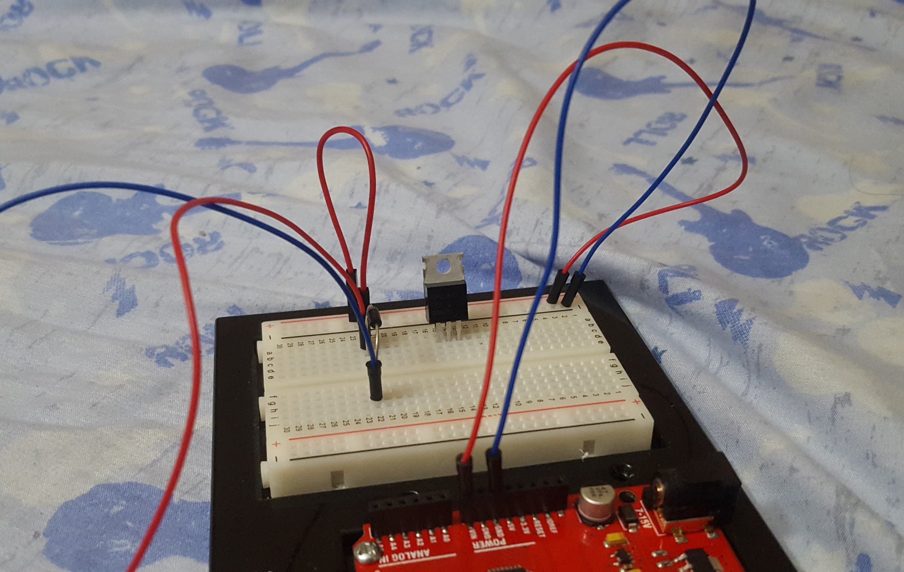

**Step 6 - Base Resistor**

This step actually sound like a connect resistor to the base of the transistor

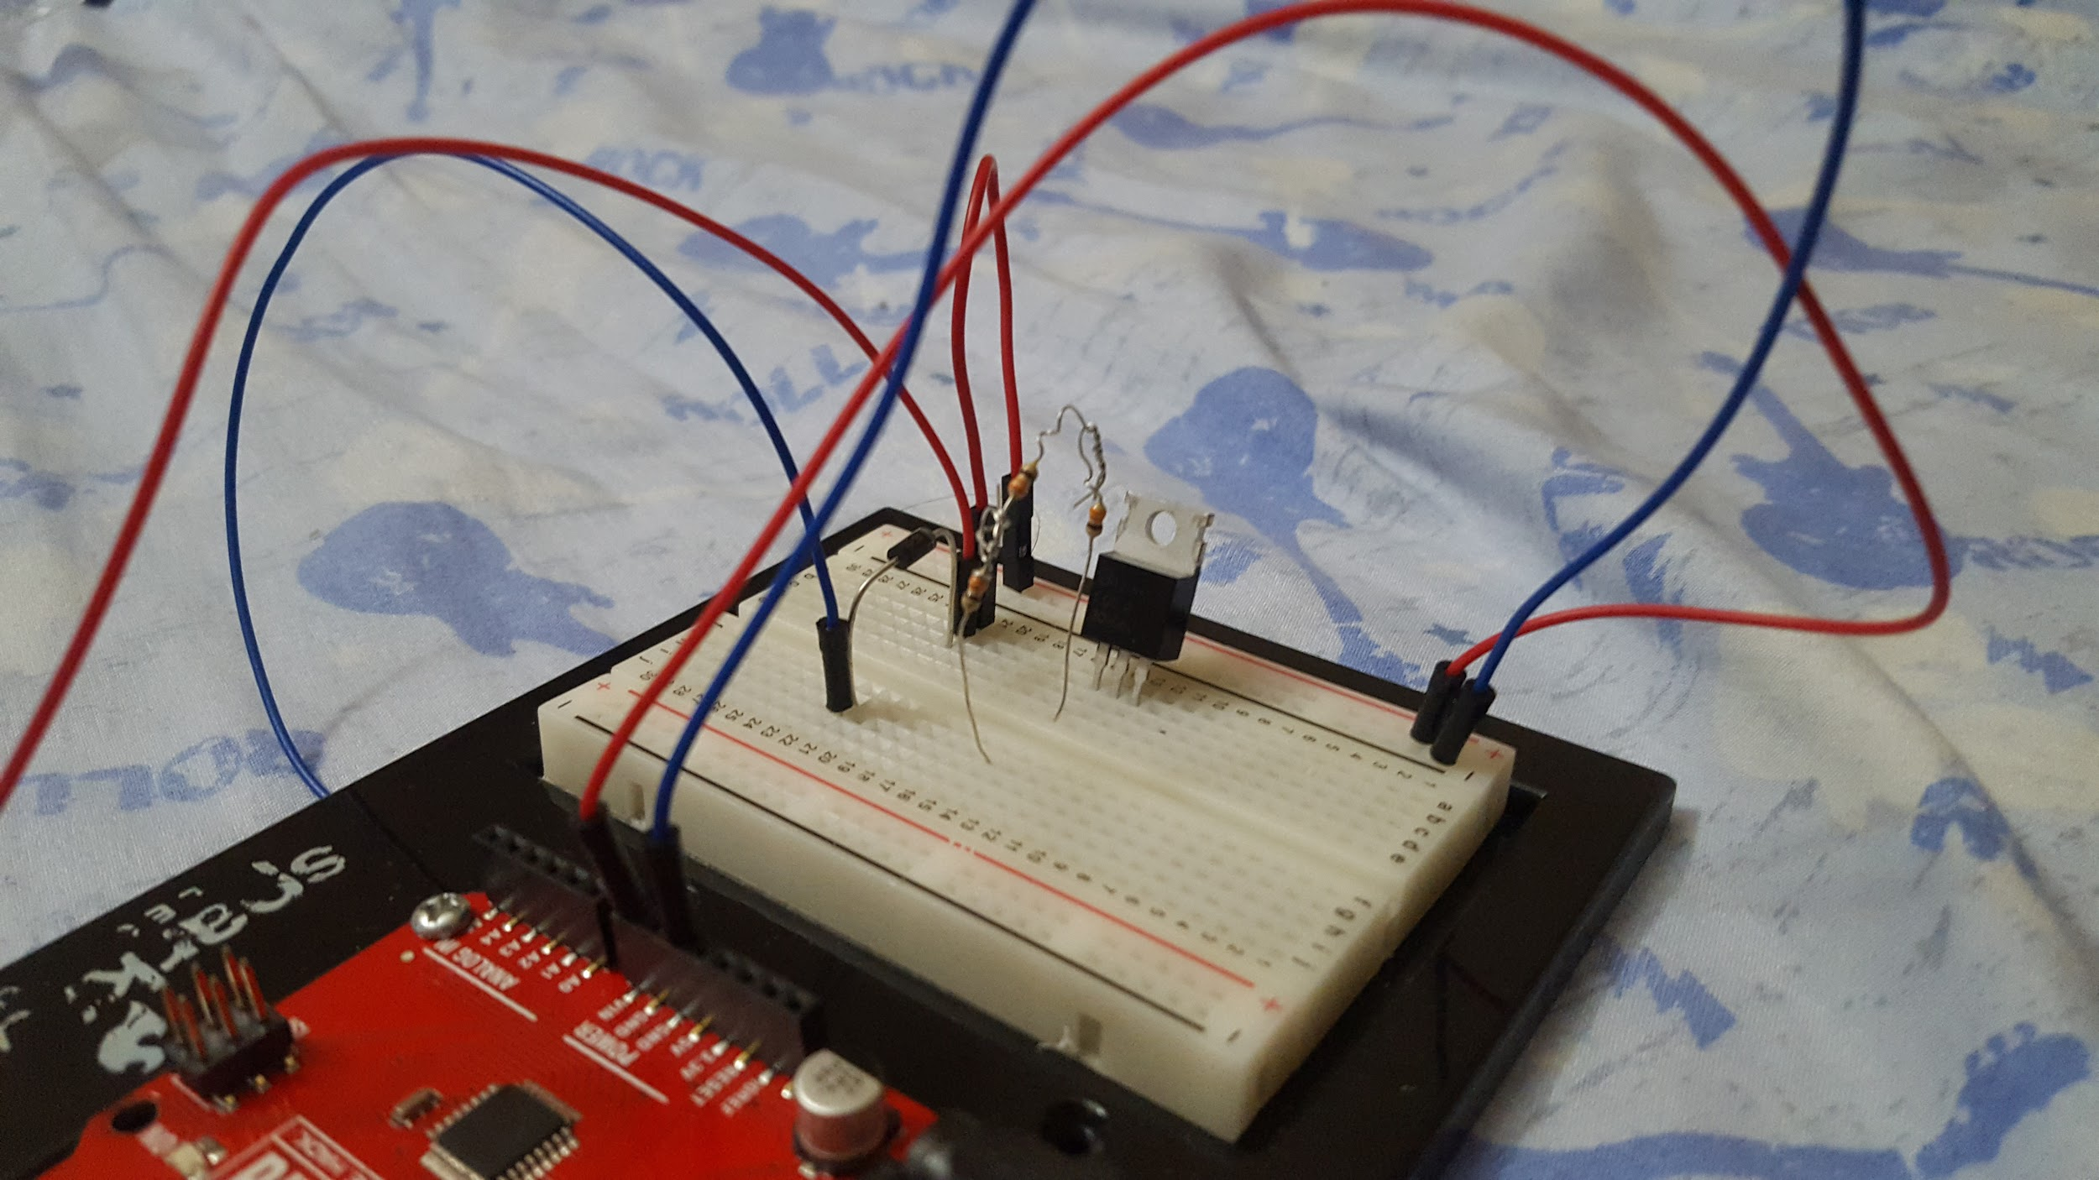

**Step 7- Connecting resistor to the Sunpark Redboard**

Now that the current limiting resistor is place we can go head to connect the it up to pin 4 on digital line of Redboard.

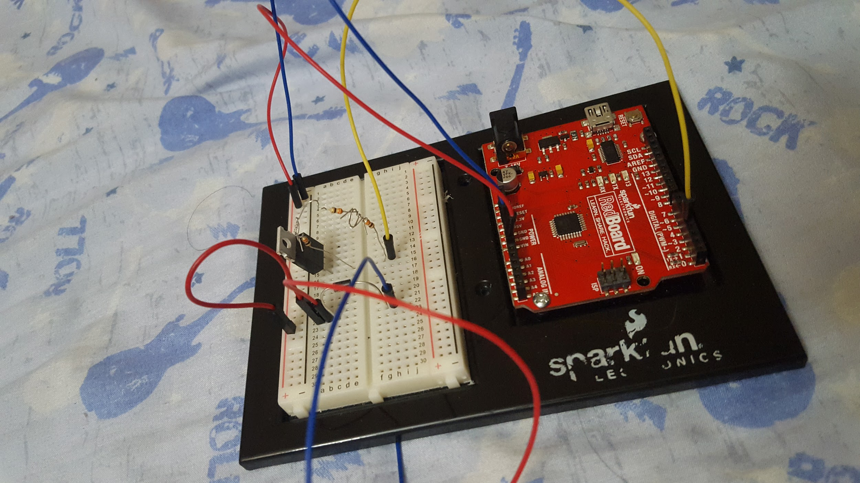

Picture of Hardware all connected together. Can include multiple pictures.

**Step 8 - Connect to another wire solenoid**

This step we connect the negative wire solenoid to middle base of transistor

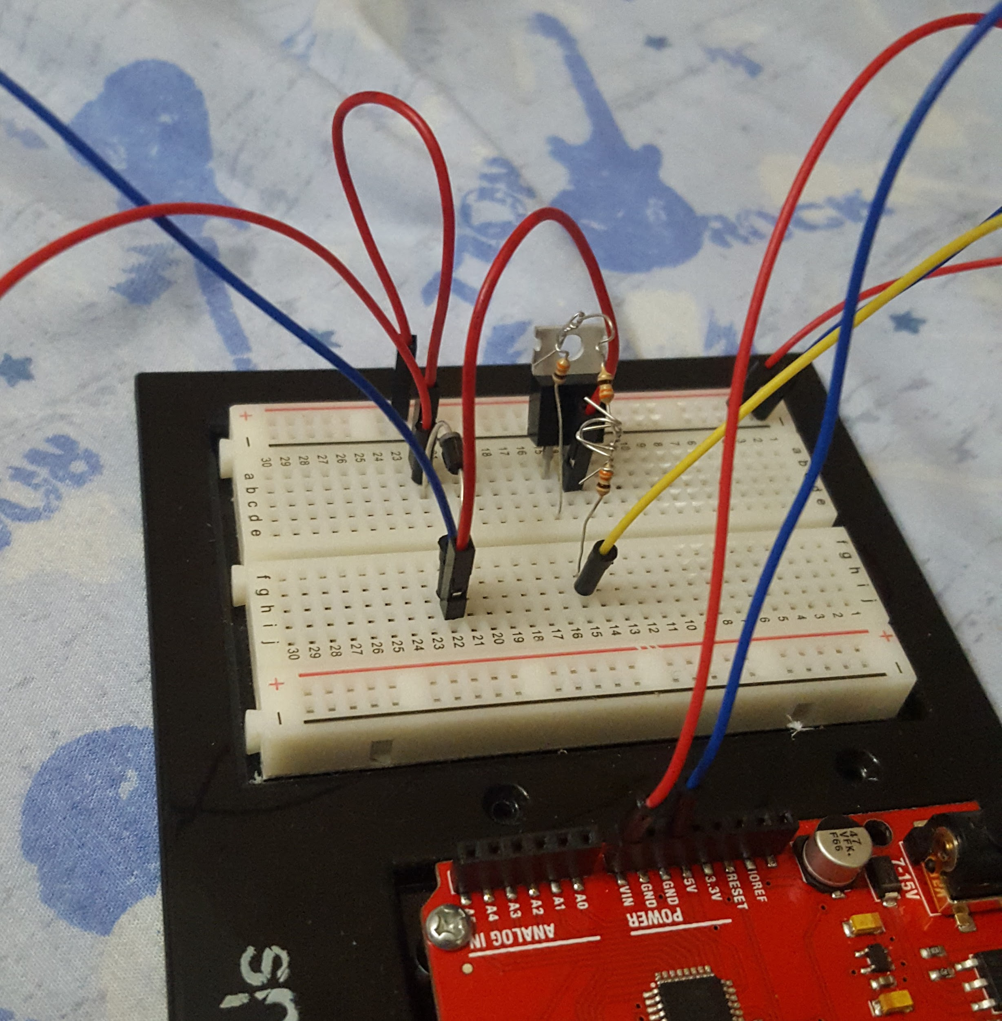

**Step 9 - Connect to the ground**

This step we connect the negative power on breadboard to left base of transistor. Make sure you connect it to right way below the image

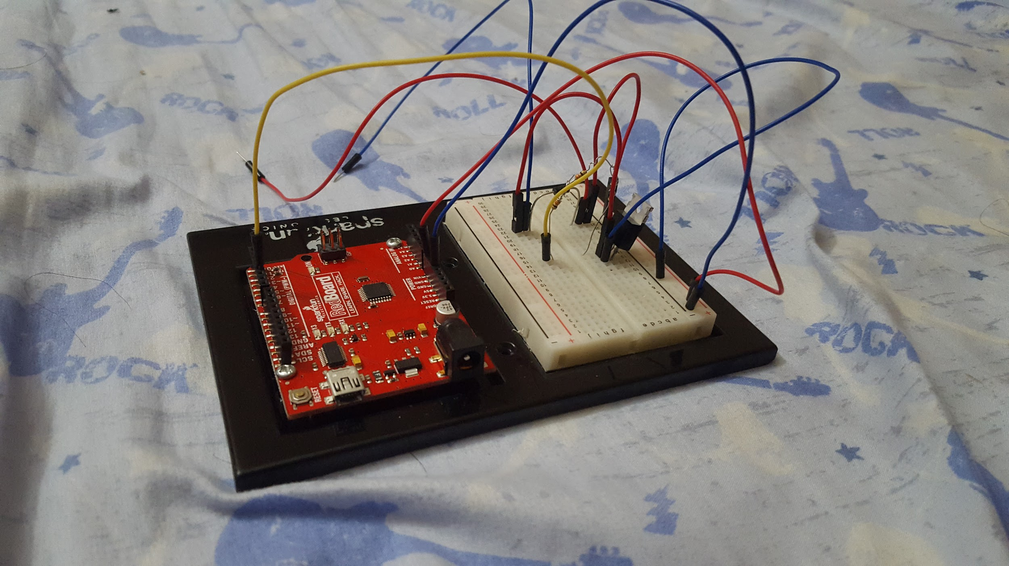

**Step 10 - connect solenoid and plus in the power**

This step we connect solenoid to the solenoid wire that we leave them on the board and then double check the connection again and plus power and cable in

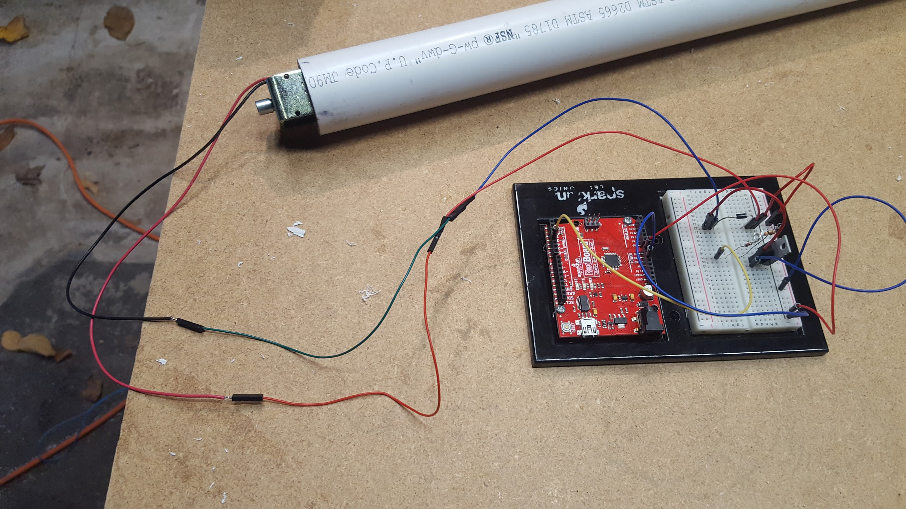

**Step 11**

Place the whole board inside of the job box make sure you make 2 holes for plus power and cable for connecting with laptop.

